**Step 1: Select Flows from setup**

From the Setup menu, select Flows.

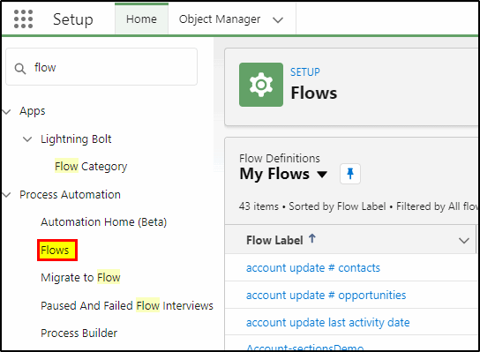

**Step 2: Create a new flow**

On the top right select **New Flow**

Select **Record-Triggered Flow** from the menu.

A record triggered flow runs in the background and is triggered on the record being created, updated or deleted. There is no user input to the flow, it is invisible to the user.

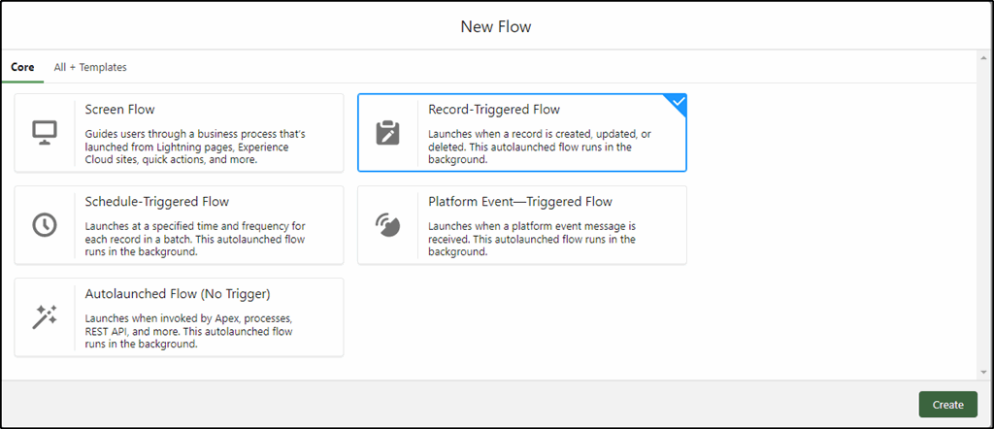

**Step 3: Configure the Start Element**

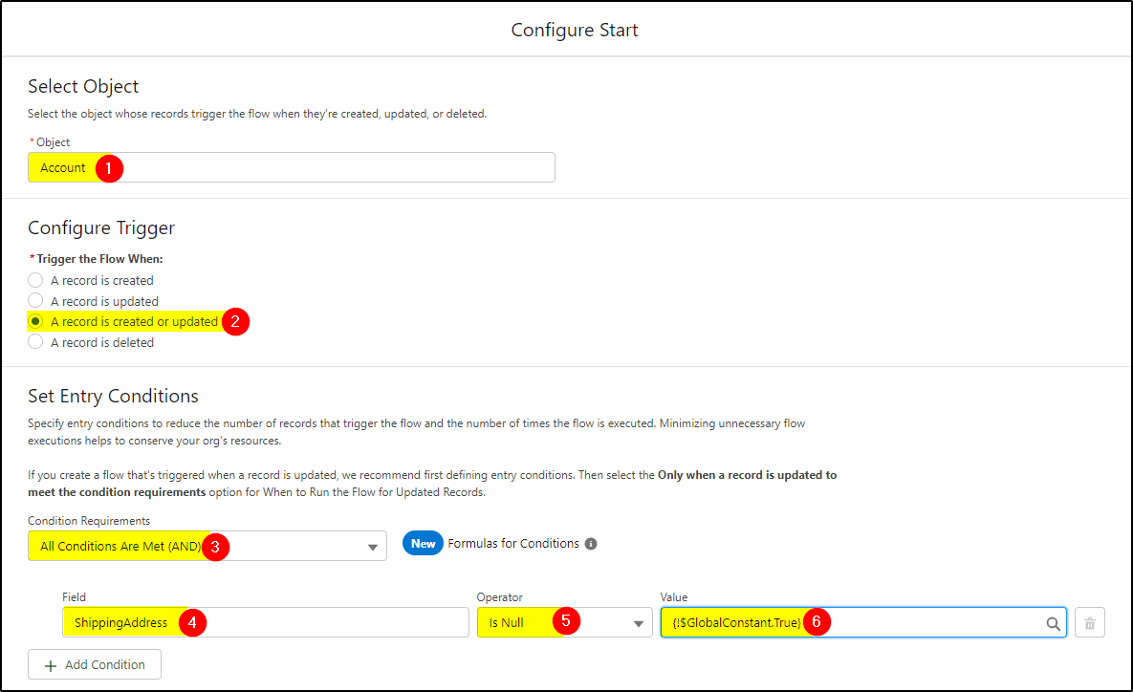

Select the Account object (1) – this is where your records reside.

Select the trigger (2) to run on both new or updated account records.

Select the Condition Requirements (AND) – (3)

The Field used to trigger will be **Shipping Address** (4) the operator is “**Is Null**” (meaning it is empty) – (5) and finally select the **$GlobalContstant.True** (6).

This last line simply means our condition to run this flow is if the Shipping Address is empty.

**Don’t click done yet! There is more to complete on this page, scroll the page up and complete the rest.**

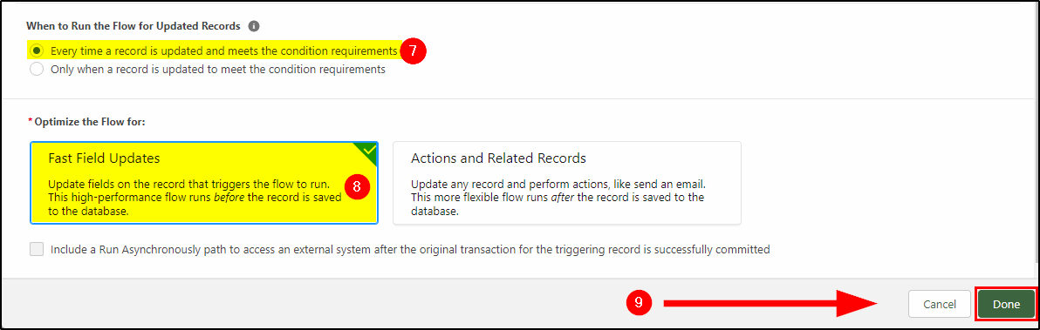

Run the flow for Updated records: **Every time a record is updated and meets the condition requirements** (7)

Select **Fast Field Updates** (8) – this makes it really quick to run.

Now you can click **Done** (9).

**Step 4: Add the Update Element**

Next, click the “+” sign below the start to add another element.

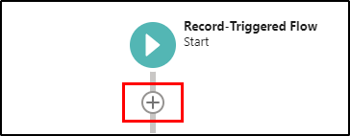

Select the **Update Triggering Record** element.

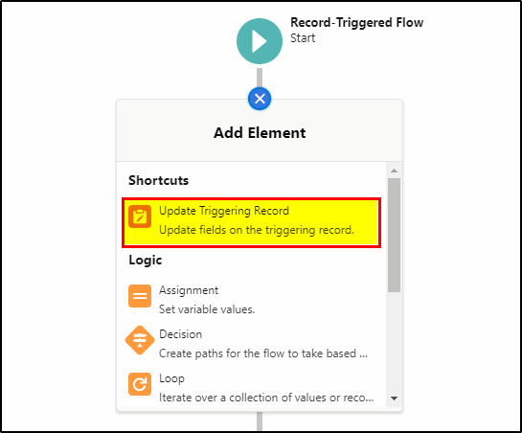

Configure this element as follows:

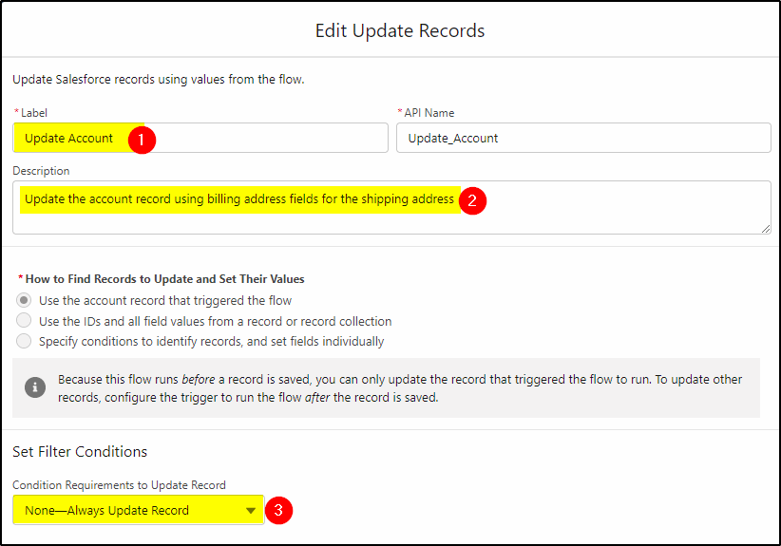

**Give the element a Label** (1)

**Add a description** so others know what is being done here (2)

Select **None-Always Update Record** (3) as we have specified the criteria in our start element.

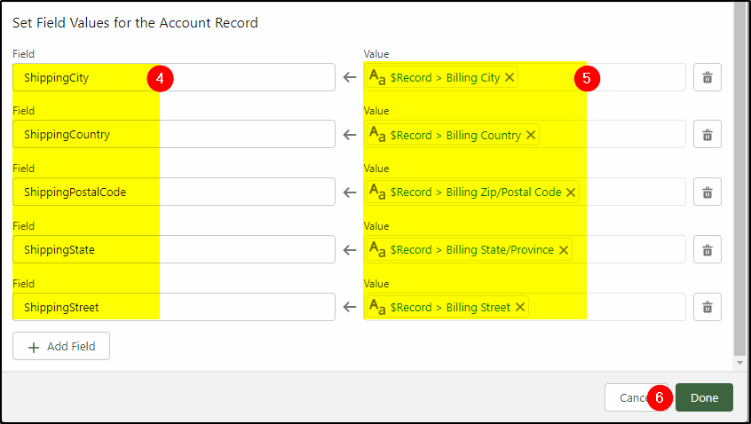

Populate the new Shipping Address fields (4) with their Billing Address values (5).

To find the $Record fields (these are the values of the existing record – even if not saved yet), click in the field on the right (1) and then scroll the list of available fields until you find $Record (2). Now click the > and select the field you need.

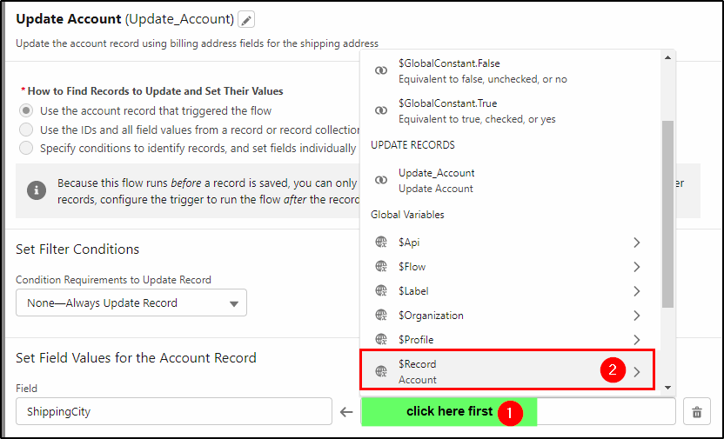

Now you can click **Done**.

**Step 5: Save and Activate the Flow**

Click the **Save** button on the top right of the page.

Click the **Activate** button to activate the flow and make it available or use.

**Step 6: Test the Flow**

Create a new Account or edit an existing one and leave the Shipping Address completely blank. The flow will run immediately you click save and will populate the Shipping Address with the same address as the Billing Address.